ABSTRACT

Chatbot are software agents that interact with the user in a conversation. The main goal of their creation was to resemble a human being in the way they perform said interaction, trying to make the user think he/she is writing to another human being. The modular chatbot is an easily adaptable chatbot system to suit specific purposes. The bot will read and understand the messages sent to it and formulate effective responses to converse with the user. The bot uses a Deep Neural Network to learn conversations in its domain. The incoming messages are analysed by the Deep Neural Network and replies are formulated. The bot uses the open source TFLearn framework built on tensorflow for python to implement the neural network. The chatbot will be modular in the sense that by using different domain specific data sets to train the neural network the bot can be adapted for different domains. The engine being completely separate from preprocessing multiple interfaces can be plugged on top of the chatbot core.

TFLEARN

TFlearn is a modular and transparent deep learning library built on top of Tensorflow. It was designed to provide a higher-level API to TensorFlow in order to facilitate and speed-up experimentations, while remaining fully transparent and compatible with it.
TFLearn features include:
- Easy-to-use and understand high-level API for implementing deep neural networks, with tutorial and examples.
- Fast prototyping through highly modular built-in neural network layers, regularizers, optimizers, metrics...
- Full transparency over Tensorflow. All functions are built over tensors and can be used independently of TFLearn.
- Powerful helper functions to train any TensorFlow graph, with support of multiple inputs, outputs and optimizers.
- Easy and beautiful graph visualization, with details about weights, gradients, activations and more...
- Effortless device placement for using multiple CPU/GPU.
The high-level API currently supports most of recent deep learning models, such as Convolutions, LSTM, BiRNN, BatchNorm, PReLU, Residual networks, Generative networks... In the future, TFLearn is also intended to stay up-to-date with latest deep learning techniques.

DEEP NEURAL NETWORKS

Neural networks are a set of algorithms, modeled loosely after the human brain, that are designed to recognize patterns. They interpret sensory data through a kind of machine perception, labeling or clustering raw input. The patterns they recognize are numerical, contained in vectors, into which all real-world data, be it images, sound, text or time series, must be translated.Neural networks help us cluster and classify. You can think of them as a clustering and classification layer on top of the data you store and manage. They help to group unlabeled data according to similarities among the example inputs, and they classify data when they have a labeled dataset to train on. (Neural networks can also extract features that are fed to other algorithms for clustering and classification; so you can think of deep neural networks as components of larger machine-learning applications involving algorithms for reinforcement learning, classification and regression.)Deep learning maps inputs to outputs. It finds correlations. It is known as a “universal approximator”, because it can learn to approximate an unknown function f(x) = y between any input x and any output y, assuming they are related at all (by correlation or causation, for example). In the process of learning, a neural network finds the right f, or the correct manner of transforming x into y, whether that be f(x) = 3x + 12 or f(x) = 9x – 0.1.

Deep learning is the name we use for “stacked neural networks”; that is, networks composed of several layers.
The layers are made of nodes. A node is just a place where computation happens, loosely patterned on a neuron in the human brain, which fires when it encounters sufficient stimuli. A node combines input from the data with a set of coefficients, or weights, that either amplify or dampen that input, thereby assigning significance to inputs for the task the algorithm is trying to learn. (For example, which input is most helpful is classifying data without error?) These input-weight products are summed and the sum is passed through a node’s so-called activation function, to determine whether and to what extent that signal progresses further through the network to affect the ultimate outcome, say, an act of classification.
Here’s a diagram of what one node might look like.

A node layer is a row of those neuronlike switches that turn on or off as the input is fed through the net. Each layer’s output is simultaneously the subsequent layer’s input, starting from an initial input layer receiving your data.

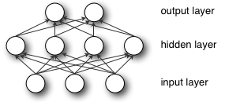

Key Concepts of Deep Neural Networks

Introduction to Deep Neural Networks (Deep Learning)
Contents
- Neural Network Definition
- A Few Concrete Examples
- Neural Network Elements
- Key Concepts of Deep Neural Networks
- Example: Feedforward Networks & Backprop
- Multiple Linear Regression
- Updaters
- Custom Layers, activation functions and loss functions
- Logistic Regression & Classifiers
- Loss Functions in DeepLearning4J
- Applying Loss Functions in DeepLearning4J
- Neural Networks & Artificial Intelligence
- Enterprise-Scale Deep Learning
- Other Introductory Resources

Neural Network Definition
Neural networks are a set of algorithms, modeled loosely after the human brain, that are designed to recognize patterns. They interpret sensory data through a kind of machine perception, labeling or clustering raw input. The patterns they recognize are numerical, contained in vectors, into which all real-world data, be it images, sound, text or time series, must be translated.
Neural networks help us cluster and classify. You can think of them as a clustering and classification layer on top of the data you store and manage. They help to group unlabeled data according to similarities among the example inputs, and they classify data when they have a labeled dataset to train on. (Neural networks can also extract features that are fed to other algorithms for clustering and classification; so you can think of deep neural networks as components of larger machine-learning applications involving algorithms for reinforcement learning, classification and regression.)
GET STARTED WITH DEEP LEARNING
What kind of problems does deep learning solve, and more importantly, can it solve yours? To know the answer, you need to ask yourself a few questions: What outcomes do I care about? Those outcomes are labels that could be applied to data: for example, spam or not_spam in an email filter, good_guy or bad_guy in fraud detection, angry_customer or happy_customer in customer relationship management.
Then ask: Do I have the data to accompany those labels? That is, can I find labeled data, or can I create a labeled dataset (with a service like AWS Mechanical Turk or Figure Eight or Mighty.ai) where spam has been labeled as spam, in order to teach an algorithm the correlation between labels and inputs?

A Few Concrete Examples
Deep learning maps inputs to outputs. It finds correlations. It is known as a “universal approximator”, because it can learn to approximate an unknown function f(x) = y between any input x and any output y, assuming they are related at all (by correlation or causation, for example). In the process of learning, a neural network finds the right f, or the correct manner of transforming x into y, whether that be f(x) = 3x + 12 or f(x) = 9x - 0.1. Here are a few examples of what deep learning can do.

Classification
All classification tasks depend upon labeled datasets; that is, humans must transfer their knowledge to the dataset in order for a neural to learn the correlation between labels and data. This is known as supervised learning.
- Detect faces, identify people in images, recognize facial expressions (angry, joyful)
- Identify objects in images (stop signs, pedestrians, lane markers…)
- Recognize gestures in video
- Detect voices, identify speakers, transcribe speech to text, recognize sentiment in voices
- Classify text as spam (in emails), or fraudulent (in insurance claims); recognize sentiment in text (customer feedback)
Any labels that humans can generate, any outcomes you care about and which correlate to data, can be used to train a neural network.

Clustering
Clustering or grouping is the detection of similarities. Deep learning does not require labels to detect similarities. Learning without labels is called unsupervised learning. Unlabeled data is the majority of data in the world. One law of machine learning is: the more data an algorithm can train on, the more accurate it will be. Therefore, unsupervised learning has the potential to produce highly accurate models.
- Search: Comparing documents, images or sounds to surface similar items.
- Anomaly detection: The flipside of detecting similarities is detecting anomalies, or unusual behavior. In many cases, unusual behavior correlates highly with things you want to detect and prevent, such as fraud.

Predictive Analytics: Regressions
With classification, deep learning is able to establish correlations between, say, pixels in an image and the name of a person. You might call this a static prediction. By the same token, exposed to enough of the right data, deep learning is able to establish correlations between present events and future events. It can run regression between the past and the future. The future event is like the label in a sense. Deep learning doesn’t necessarily care about time, or the fact that something hasn’t happened yet. Given a time series, deep learning may read a string of number and predict the number most likely to occur next.
- Hardware breakdowns (data centers, manufacturing, transport)
- Health breakdowns (strokes, heart attacks based on vital stats and data from wearables)
- Customer churn (predicting the likelihood that a customer will leave, based on web activity and metadata)
- Employee turnover (ditto, but for employees)
The better we can predict, the better we can prevent and pre-empt. As you can see, with neural networks, we’re moving towards a world of fewer surprises. Not zero surprises, just marginally fewer. We’re also moving toward a world of smarter agents that combine neural networks with other algorithms like reinforcement learning to attain goals.
With that brief overview of deep learning use cases, let’s look at what neural nets are made of.

Neural Network Elements
Deep learning is the name we use for “stacked neural networks”; that is, networks composed of several layers.
The layers are made of nodes. A node is just a place where computation happens, loosely patterned on a neuron in the human brain, which fires when it encounters sufficient stimuli. A node combines input from the data with a set of coefficients, or weights, that either amplify or dampen that input, thereby assigning significance to inputs for the task the algorithm is trying to learn. (For example, which input is most helpful is classifying data without error?) These input-weight products are summed and the sum is passed through a node’s so-called activation function, to determine whether and to what extent that signal progresses further through the network to affect the ultimate outcome, say, an act of classification.
Here’s a diagram of what one node might look like.
A node layer is a row of those neuronlike switches that turn on or off as the input is fed through the net. Each layer’s output is simultaneously the subsequent layer’s input, starting from an initial input layer receiving your data.
Pairing adjustable weights with input features is how we assign significance to those features with regard to how the network classifies and clusters input.

Key Concepts of Deep Neural Networks
Deep-learning networks are distinguished from the more commonplace single-hidden-layer neural networks by their depth; that is, the number of node layers through which data passes in a multistep process of pattern recognition.
Earlier versions of neural networks such as the first perceptrons were shallow, composed of one input and one output layer, and at most one hidden layer in between. More than three layers (including input and output) qualifies as “deep” learning. So deep is a strictly defined, technical term that means more than one hidden layer.
In deep-learning networks, each layer of nodes trains on a distinct set of features based on the previous layer’s output. The further you advance into the neural net, the more complex the features your nodes can recognize, since they aggregate and recombine features from the previous layer.
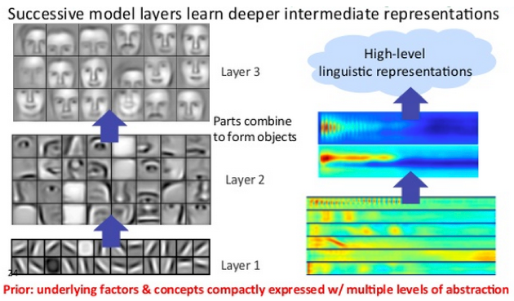
This is known as feature hierarchy, and it is a hierarchy of increasing complexity and abstraction. It makes deep-learning networks capable of handling very large, high-dimensional data sets with billions of parameters that pass through nonlinear functions.
Above all, these nets are capable of discovering latent structures within unlabeled, unstructured data, which is the vast majority of data in the world. Another word for unstructured data is raw media; i.e. pictures, texts, video and audio recordings. Therefore, one of the problems deep learning solves best is in processing and clustering the world’s raw, unlabeled media, discerning similarities and anomalies in data that no human has organized in a relational database or ever put a name to.
For example, deep learning can take a million images, and cluster them according to their similarities: cats in one corner, ice breakers in another, and in a third all the photos of your grandmother. This is the basis of so-called smart photo albums.
Now apply that same idea to other data types: Deep learning might cluster raw text such as emails or news articles. Emails full of angry complaints might cluster in one corner of the vector space, while satisfied customers, or spambot messages, might cluster in others. This is the basis of various messaging filters, and can be used in customer-relationship management (CRM). The same applies to voice messages. With time series, data might cluster around normal/healthy behavior and anomalous/dangerous behavior. If the time series data is being generated by a smart phone, it will provide insight into users’ health and habits; if it is being generated by an autopart, it might be used to prevent catastrophic breakdowns.
Deep-learning networks perform automatic feature extraction without human intervention, unlike most traditional machine-learning algorithms. Given that feature extraction is a task that can take teams of data scientists years to accomplish, deep learning is a way to circumvent the chokepoint of limited experts. It augments the powers of small data science teams, which by their nature do not scale.
When training on unlabeled data, each node layer in a deep network learns features automatically by repeatedly trying to reconstruct the input from which it draws its samples, attempting to minimize the difference between the network’s guesses and the probability distribution of the input data itself. Restricted Boltzmann machines, for examples, create so-called reconstructions in this manner.
In the process, these networks learn to recognize correlations between certain relevant features and optimal results – they draw connections between feature signals and what those features represent, whether it be a full reconstruction, or with labeled data.
A deep-learning network trained on labeled data can then be applied to unstructured data, giving it access to much more input than machine-learning nets. This is a recipe for higher performance: the more data a net can train on, the more accurate it is likely to be. (Bad algorithms trained on lots of data can outperform good algorithms trained on very little.) Deep learning’s ability to process and learn from huge quantities of unlabeled data give it a distinct advantage over previous algorithms.
Deep-learning networks end in an output layer: a logistic, or softmax, classifier that assigns a likelihood to a particular outcome or label. We call that predictive, but it is predictive in a broad sense. Given raw data in the form of an image, a deep-learning network may decide, for example, that the input data is 90 percent likely to represent a person.

SOFTMAX FUNCTION

In mathematics, the softmax function, or normalized exponential function,[1]:198 is a generalization of the logistic function that "squashes" a K-dimensional vector z {\displaystyle \mathbf {z} } of arbitrary real values to a K-dimensional vector σ ( z ) {\displaystyle \sigma (\mathbf {z} )} of real values in the range (0, 1) that add up to 1. The function is given by
σ : R K → ( 0 , 1 ) K {\displaystyle \sigma :\mathbb {R} ^{K}\to (0,1)^{K}}
σ ( z j ) = e z j ∑ k = 1 K e z k {\displaystyle \sigma (\mathbf {z} _{j})={\frac {e^{z_{j}}}{\sum _{k=1}^{K}e^{z_{k}}}}} for j = 1, …, K.
In probability theory, the output of the softmax function can be used to represent a categorical distribution – that is, a probability distribution over K different possible outcomes. In fact, it is the gradient-log-normalizer of the categorical probability distribution.[further explanation needed][citation needed]
The softmax function is used in various multiclass classification methods, such as multinomial logistic regression (also known as softmax regression)[1]:206–209 [1], multiclass linear discriminant analysis, naive Bayes classifiers, and artificial neural networks.[2] Specifically, in multinomial logistic regression and linear discriminant analysis, the input to the function is the result of K distinct linear functions, and the predicted probability for the j'th class given a sample vector x and a weighting vector w is:
P ( y = j ∣ x ) = e x T w j ∑ k = 1 K e x T w k {\displaystyle P(y=j\mid \mathbf {x} )={\frac {e^{\mathbf {x} ^{\mathsf {T}}\mathbf {w} _{j}}}{\sum _{k=1}^{K}e^{\mathbf {x} ^{\mathsf {T}}\mathbf {w} _{k}}}}}
This can be seen as the composition of K linear functions x ↦ x T w 1 , … , x ↦ x T w K {\displaystyle \mathbf {x} \mapsto \mathbf {x} ^{\mathsf {T}}\mathbf {w} _{1},\ldots ,\mathbf {x} \mapsto \mathbf {x} ^{\mathsf {T}}\mathbf {w} _{K}} and the softmax function (where x T w {\displaystyle \mathbf {x} ^{\mathsf {T}}\mathbf {w} } denotes the inner product of x {\displaystyle \mathbf {x} } and w {\displaystyle \mathbf {w} } ). The operation is equivalent to applying a linear operator defined by w {\displaystyle \mathbf {w} } to vectors x {\displaystyle \mathbf {x} } , thus transforming the original, probably highly-dimensional, input to vectors in a K-dimensional space R K {\displaystyle \mathbb {R} ^{K}} .

If we take an input of [1, 2, 3, 4, 1, 2, 3], the softmax of that is [0.024, 0.064, 0.175, 0.475, 0.024, 0.064, 0.175]. The output has most of its weight where the '4' was in the original input. This is what the function is normally used for: to highlight the largest values and suppress values which are significantly below the maximum value. But note: softmax is not scale invariant, so if the input were [0.1, 0.2, 0.3, 0.4, 0.1, 0.2, 0.3] (which sums to 1.6) the softmax would be [0.125, 0.138, 0.153, 0.169, 0.125, 0.138, 0.153]. This shows that for values between 0 and 1 softmax in fact de-emphasizes the maximum value (note that 0.169 is not only less than 0.475, it is also less than the initial value of 0.4).
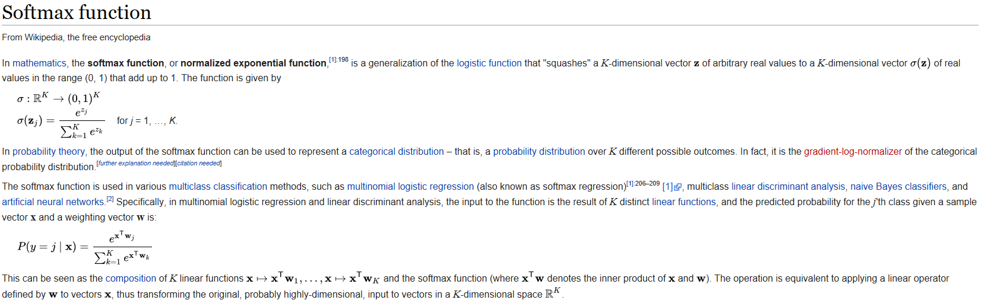

Neural networks[edit]
The softmax function is often used in the final layer of a neural network-based classifier. Such networks are commonly trained under a log loss (or cross-entropy) regime, giving a non-linear variant of multinomial logistic regression.
Since the function maps a vector and a specific index i to a real value, the derivative needs to take the index into account:

Here, the Kronecker delta is used for simplicity (cf. the derivative of a sigmoid function, being expressed via the function itself).
See Multinomial logit for a probability model which uses the softmax activation function.
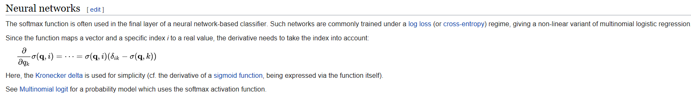

TENSORFLOW
TensorFlow is an open source software library for numerical computation using data-flow graphs. It was originally developed by the Google Brain Team within Google's Machine Intelligence research organization for machine learning and deep neural networks research, but the system is general enough to be applicable in a wide variety of other domains as well. It reached version 1.0 in February 2017, and has continued rapid development, with 21,000+ commits thus far, many from outside contributors. This article introduces TensorFlow, its open source community and ecosystem, and highlights some interesting TensorFlow open sourced models.
TensorFlow is cross-platform. It runs on nearly everything: GPUs and CPUs—including mobile and embedded platforms—and even tensor processing units (TPUs), which are specialized hardware to do tensor math on.
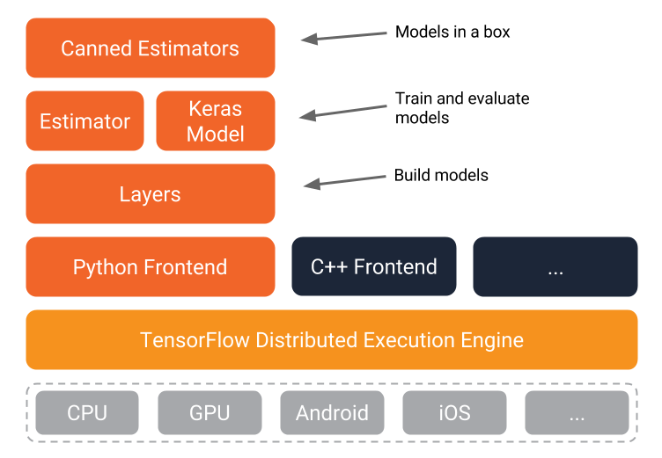

The TensorFlow distributed execution engine abstracts away the many supported devices and provides a high performance-core implemented in C++ for the TensorFlow platform.On top of that sit the Python and C++ frontends (with more to come). The Layers API provides a simpler interface for commonly used layers in deep learning models. On top of that sit higher-level APIs, including Keras (more on the Keras.io site) and the Estimator API, which makes training and evaluating distributed models easier.And finally, a number of commonly used models are ready to use out of the box, with more to come.

TensorFlow execution model

Graphs
Machine learning can get complex quickly, and deep learning models can become large. For many model graphs, you need distributed training to be able to iterate within a reasonable time frame. And, you'll typically want the models you develop to deploy to multiple platforms.
With the current version of TensorFlow, you write code to build a computation graph, then execute it. The graph is a data structure that fully describes the computation you want to perform. This has lots of advantages:
- It's portable, as the graph can be executed immediately or saved to use later, and it can run on multiple platforms: CPUs, GPUs, TPUs, mobile, embedded. Also, it can be deployed to production without having to depend on any of the code that built the graph, only the runtime necessary to execute it.
- It's transformable and optimizable, as the graph can be transformed to produce a more optimal version for a given platform. Also, memory or compute optimizations can be performed and trade-offs made between them. This is useful, for example, in supporting faster mobile inference after training on larger machines.
- Support for distributed execution
TensorFlow's high-level APIs, in conjunction with computation graphs, enable a rich and flexible development environment and powerful production capabilities in the same framework.

Eager execution
An upcoming addition to TensorFlow is eager execution, an imperative style for writing TensorFlow. When you enable eager execution, you will be executing TensorFlow kernels immediately, rather than constructing graphs that will be executed later.
Why is this important? Four major reasons:
- You can inspect and debug intermediate values in your graph easily.
- You can use Python control flow within TensorFlow APIs—loops, conditionals, functions, closures, etc.
- Eager execution should make debugging more straightforward.
- Eager's "define-by-run" semantics will make building and training dynamic graphs easy.
Once you are satisfied with your TensorFlow code running eagerly, you can convert it to a graph automatically. This will make it easier to save, port, and distribute your graphs.
This interface is in its early (pre-alpha) stages. Follow along on GitHub.

TensorFlow and the open source software community
TensorFlow was open sourced in large part to allow the community to improve it with contributions. The TensorFlow team has set up processes to manage pull requests, review and route issues filed, and answer Stack Overflow and mailing list questions.
So far, we've had more than 890 external contributors add to the code, with everything from small documentation fixes to large additions like OS X GPU support or the OpenCL implementation. (The broader TensorFlow GitHub organization has had nearly 1,000 unique non-Googler contributors.)
Tensorflow has more than 76,000 stars on GitHub, and the number of other repos that use it is growing every month—as of this writing, there are more than 20,000.
Many of these are community-created tutorials, models, translations, and projects. They can be a great source of examples if you're getting started on a machine learning task.
Stack Overflow is monitored by the TensorFlow team, and it's a good way to get questions answered (with 8,000+ answered so far).
The external version of TensorFlow internally is no different than internal, beyond some minor differences. These include the interface to Google's internal infrastructure (it would be no help to anyone), some paths, and parts that aren't ready yet. The core of TensorFlow, however, is identical. Pull requests to internal will appear externally within around a day and a half and vice-versa.
In the TensorFlow GitHub org, you can find not only TensorFlow itself, but a useful ecosystem of other repos, including models, serving, TensorBoard, Project Magenta, and many more. (A few of these are described below). You can also find TensorFlow APIs in multiple languages (Python, C++, Java, and Go); and the community has developed other bindings, including C#, Haskell, Julia, Ruby, Rust, and Scala.

Performance and benchmarking
TensorFlow has high standards around measurement and transparency. The team has developed a set of detailed benchmarks and has been very careful to include all necessary details to reproduce. We've not yet run comparative benchmarks, but would welcome for others to publish comprehensive and reproducible benchmarks.
There's a section of the TensorFlow site with information specifically for performance-minded developers. Optimization can often be model-specific, but there are some general guidelines that can often make a big difference.

TensorFlow's open source models
The TensorFlow team has open sourced a large number of models. You can find them in the tensorflow/models repo. For many of these, the released code includes not only the model graph, but also trained model weights. This means that you can try such models out of the box, and you can tune many of them further using a process called transfer learning.

